**Preformance test on PB-67**

|  |  |  |  |
| --- | --- | --- | --- |
| Mattias Hovde | | | |
| Datorspecifikationer | | | |
| OS | Windows 10 | **GPU** | NVIDIA GeForce GTX 1080 |
| processor | Intel(R) Core(TM) i7-6700K CPU @ 4.00GHz | | |

|  |  |  |  |
| --- | --- | --- | --- |
| RAM | 16 GB | **Systemtyp** | 64-bitars operativsystem, x64 baserad processor |

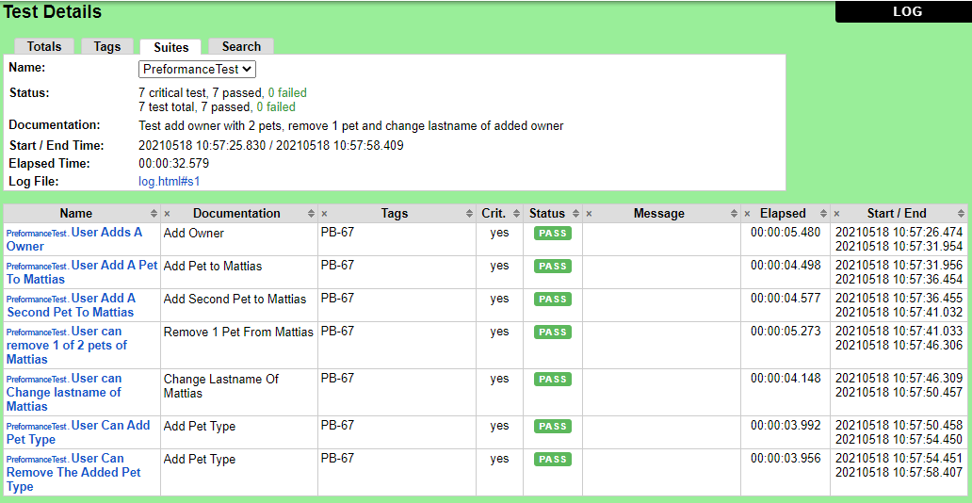

|  |  |  |  |
| --- | --- | --- | --- |
| Ruiling Cai | | | |
| Datorspecifikationer | | | |
| OS | Windows 10 | **GPU** | Intel(R) UHD Graphics 620 |
| processor | Intel(R) Core(TM) i5-8350U CPU @ 1.70GHz | | |

|  |  |  |  |
| --- | --- | --- | --- |
| RAM | 16 GB | **Systemtyp** | 64-bitars operativsystem, x64 baserad processor |

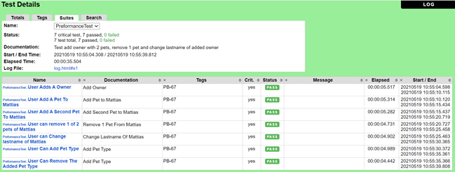

|  |  |  |  |
| --- | --- | --- | --- |
| Wasim Eljomaa | | | |
| Datorspecifikationer | | | |
| OS | Windows 10 Pro | **GPU** | Intel®HD Graphics 520 |
| processor | Intel® core™ i5-6300u CPU @2.40GHz 2.50 GHz | | |

|  |  |  |  |
| --- | --- | --- | --- |
| RAM | 8,00 GB (7,67 år att använda) | **Systemtyp** | 64-bitars operativsystem,x64 baserad processor |

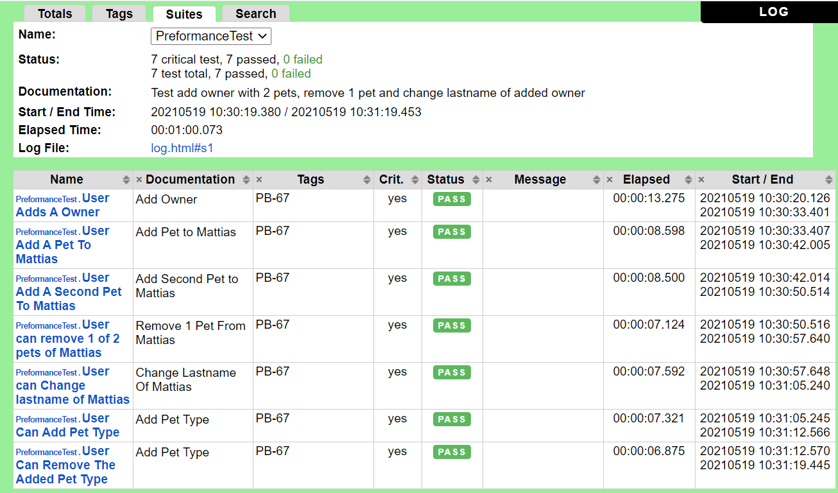

|  |  |  |  |
| --- | --- | --- | --- |
| Subhashini Penumatsa | | | |
| OS | Windows 10 Pro | **GPU** | Intel®HD Graphics 520 |
| processor | Intel(R) Core(TM) i5-6300U CPU @ 2.40GHz 2.50 GHz | | |

|  |  |  |  |
| --- | --- | --- | --- |
| RAM | 8,00 GB (7,83 GB usable) | **Systemtyp** | 64-bit operating system, x64-based processor |

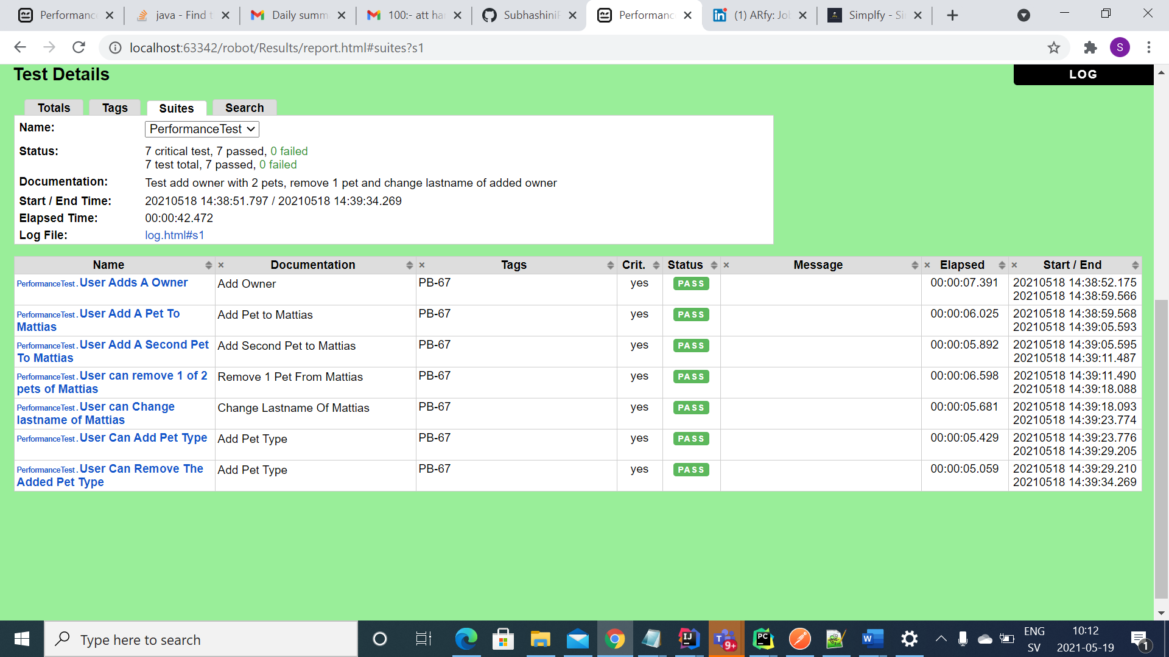

|  |  |  |  |
| --- | --- | --- | --- |
| Amer Rasheed | | | |
|  | | | |
| OS | Windows 10 Pro | **GPU** | Intel®HD Graphics 520 |
| processor | Intel(R) Core(TM) i5-4210U CPU @ 1.70GHz 2.40 GHz | | |

|  |  |  |  |
| --- | --- | --- | --- |
| RAM | 8.00 GB | **Systemtyp** | 64-bit operating system, x64-based processor |

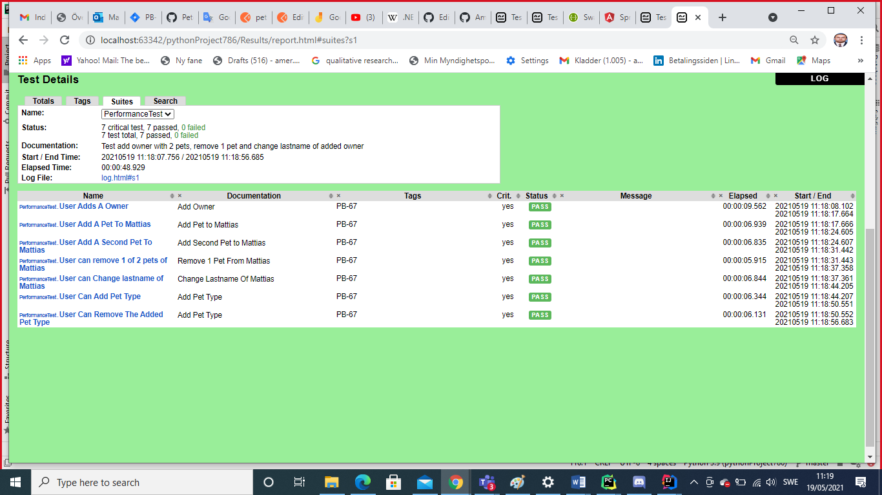

|  |  |  |  |
| --- | --- | --- | --- |
| Likkaa Johar | | | |
| Datorspecifikationer | | | |
| OS | Windows 10 pro | **GPU** | Intel®HD Graphics 520 |
| processor | Intel® core™ i5-6300u CPU @2.40GHz 2.50 GHz | | |

|  |  |  |  |
| --- | --- | --- | --- |
| RAM | 8.00 GB | **Systemtyp** | 64-bit operating system, X64- based processor |

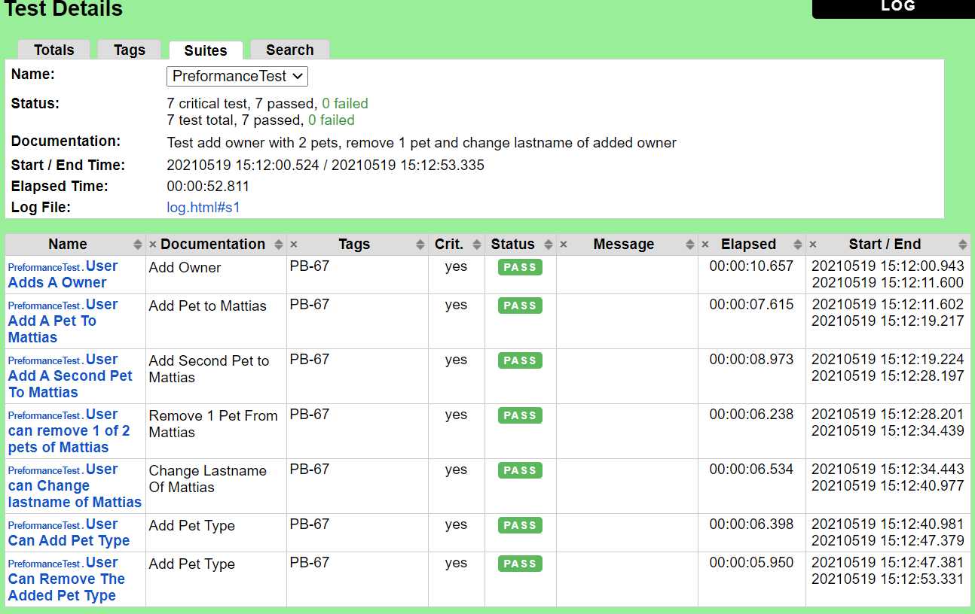

|  |  |  |  |
| --- | --- | --- | --- |
| Shilpa Srinivas | | | |
| Datorspecifikationer | | | |
| OS | Windows 10 | **GPU** | Intel®HD Graphics 520 |
| processor | Intel® core™ i5-6300u CPU @2.40GHz 2.20 GHz | | |

|  |  |  |  |
| --- | --- | --- | --- |
| RAM | 8.00 GB | **Systemtyp** | 64-bit operating system, X64- based processor |

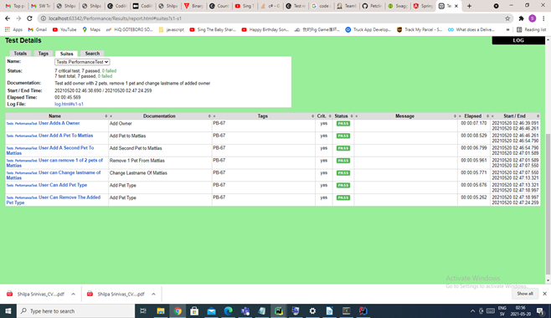

|  |  |  |  |
| --- | --- | --- | --- |
| Mattias Hovde | | | |
| Datorspecifikationer | | | |
| OS | Windows 10 | **GPU** | NVIDIA GeForce GTX 1080 |
| processor | Intel(R) Core(TM) i7-6700K CPU @ 4.00GHz | | |

|  |  |  |  |
| --- | --- | --- | --- |
| RAM | 16 GB | **Systemtyp** | 64-bitars operativsystem, x64 baserad processor |